
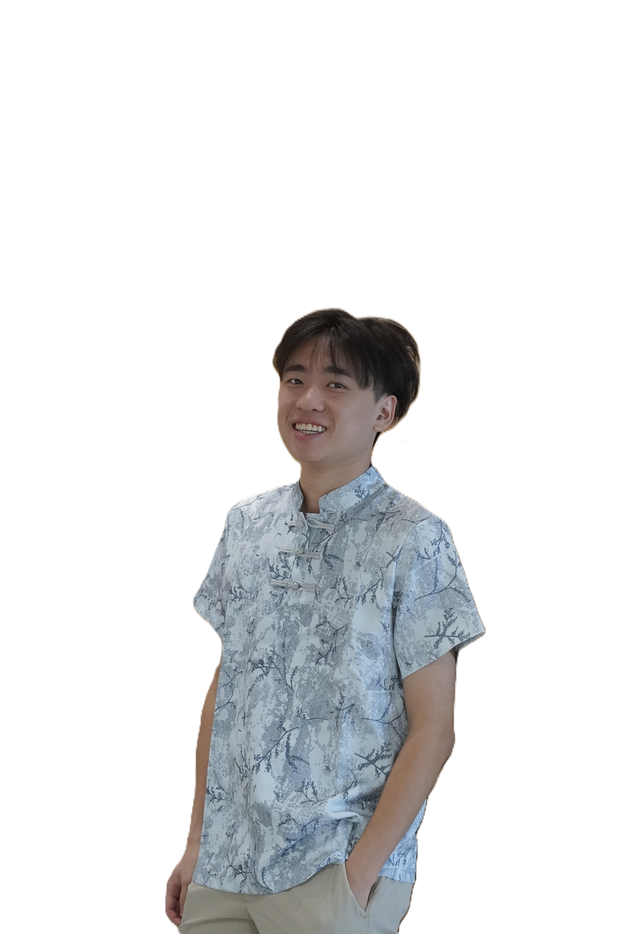
Calvin Lee
MAINFRAME & BACKEND DEVELOPER
WP. Kuala Lumpur, Malaysia
calvinlee123456@gmail.com | +60 14 644 4059

"I view AI as a force multiplier. Instead of spending hours writing syntax from scratch, I utilize advanced AI tools to handle foundational coding. This allows me to focus my energy on what matters most: high-level program planning, architectural logic, and ensuring the project aligns perfectly with business goals."

Experience
Maybank — Full Stack/ Mainframe Developer
Mar 2024 - Present
Developing in Assembler and COBOL. Responsible for implementing core banking functions and validating high-volume transaction conditions within critical financial environments.
Maybank — Mainframe Developer
Mar 2023 - Mar 2024
Focused on internal automation, scripting, and backend system optimizations prior to transitioning fully to the core mainframe architecture.

Technical Architecture
Primary Focus: JCL, COBOL, Assembler, SQL
Modern Implementations: Node.js, Python, JavaScript, PHP, MongoDB, Direct LLM APIs

Core Infrastructure Work
- Banking Automation & SAFE: Implemented Savings Related Projects (SAFE), a critical mainframe function where the vast majority of banking transactions route through, ensuring strict condition validation and system stability.
- Core AI Implementation: Acted as the primary technical tester for pushing AI usage directly inside core banking systems, ensuring secure and efficient operation of new generative technologies while mitigating data risks using safe placeholder testing.
- Internal Web Automation: Developed confidential daily monitoring websites utilizing Node.js, Python, and PHP. These tools are currently registered to and utilized by over 200 employees daily to streamline operations and map mainframe-to-open-system logic flows.

Creative AI & Interactive Architecture
- Melo Studio: A creative side project involving the use of AI to compose, produce, and generate music entirely from scratch.
- Direct API LLM Integration: Implementing raw capabilities from models like Llama, Deepseek, Kimi, and Qwen directly into custom applications, including an AI Question Guessing Game and a Google Cloud Discord Agent.
- Interactive Web Games: Developed browser-based projects like "An Imposter Game" (Multiplayer) and "Slice" to experiment with real-time websocket connections and rendering mechanics outside of traditional core banking structures.

Education
- Bachelor of Engineering - BE, Information Technology
The University of Queensland (2021 - 2022) | QS World Ranking: #46 Globally
- Bachelor's degree, Information Technology
HELP University (Aug 2018 - Dec 2020)

Speak with my AI Assistant
I have built an intelligent, custom AI agent into my portfolio. Scan the QR code below to chat with it directly to learn more about my background, technical philosophies, and experience.
🔗 https://www.calvin-lee.org/

